CREATE TABLE STUDENTNEW(Student_reg NUMBER(30),Student_Name VARCHAR2(38),Student_dob DATE);

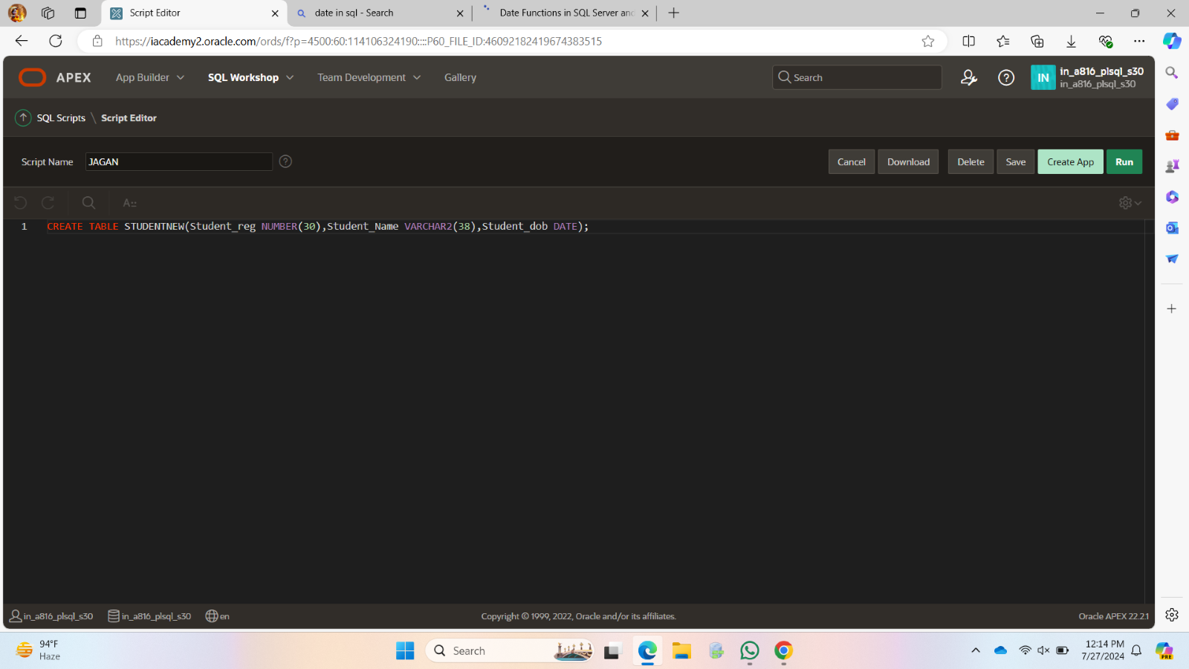  
ALTER TABLE STUDENTNEW ADD BLOOD_GROUP VARCHAR2(30);

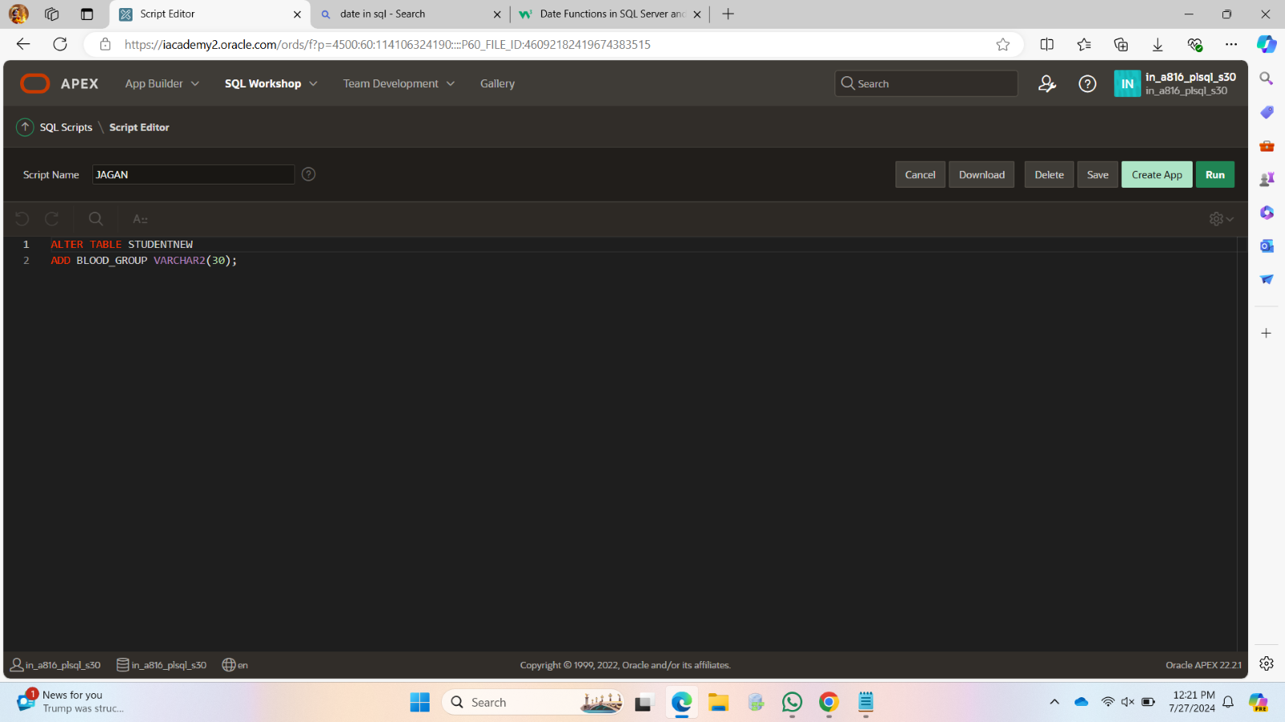  
ALTER TABLE STUDENTNEW ADD PRIMARY KEY (STUDENT_REG);

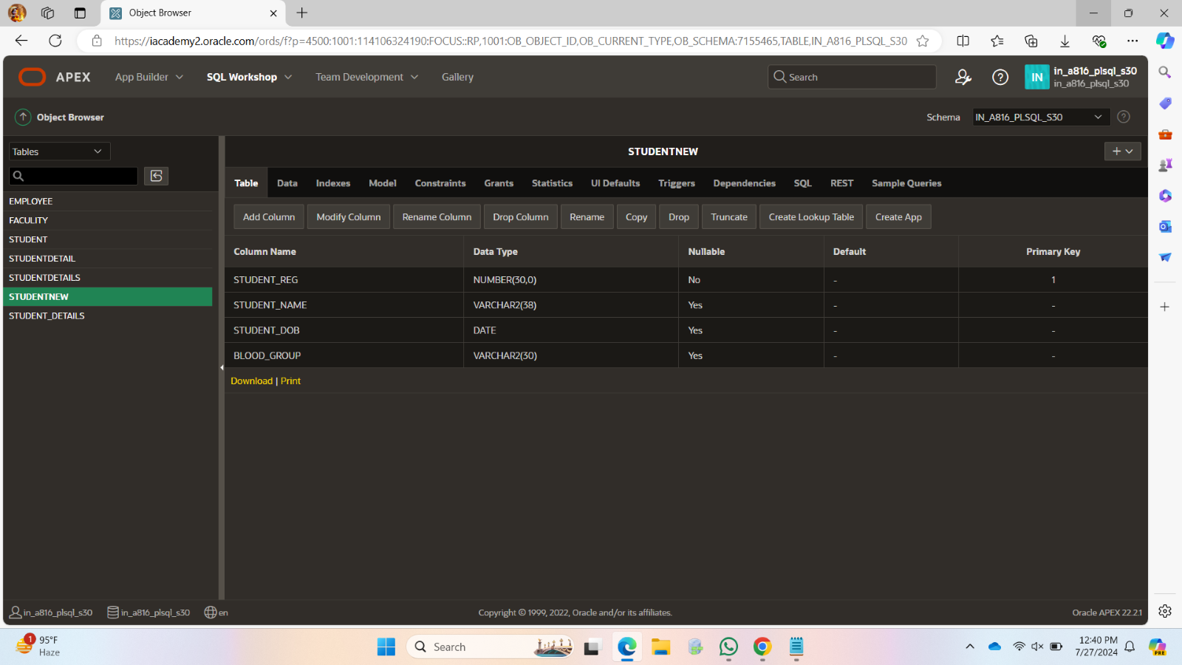  
ALTER TABLE STUDENTNEW ADD USELESS VARCHAR2(30);

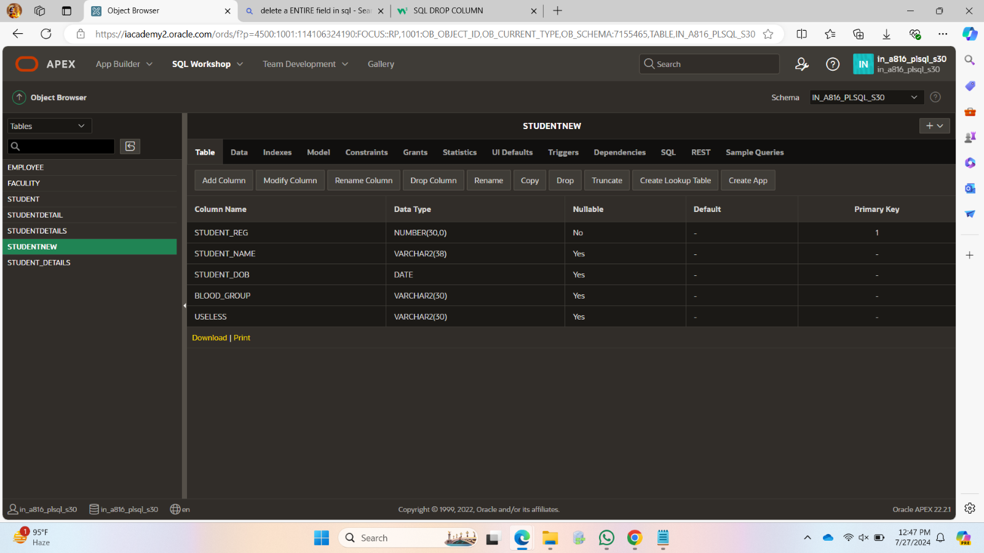

ALTER T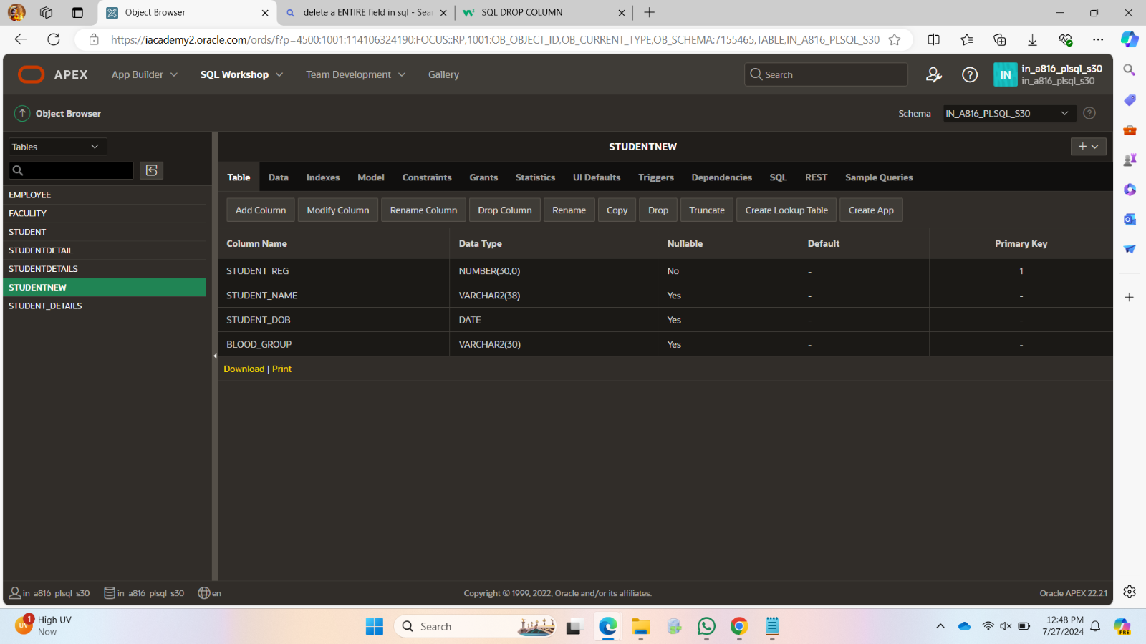  
ABLE STUDENTNEW DROP COLUMN USELESS;

ALTER TABLE STUDENTNEW

RENAME COLUMN STUDENT_REG TO STUDENT_REGNO;

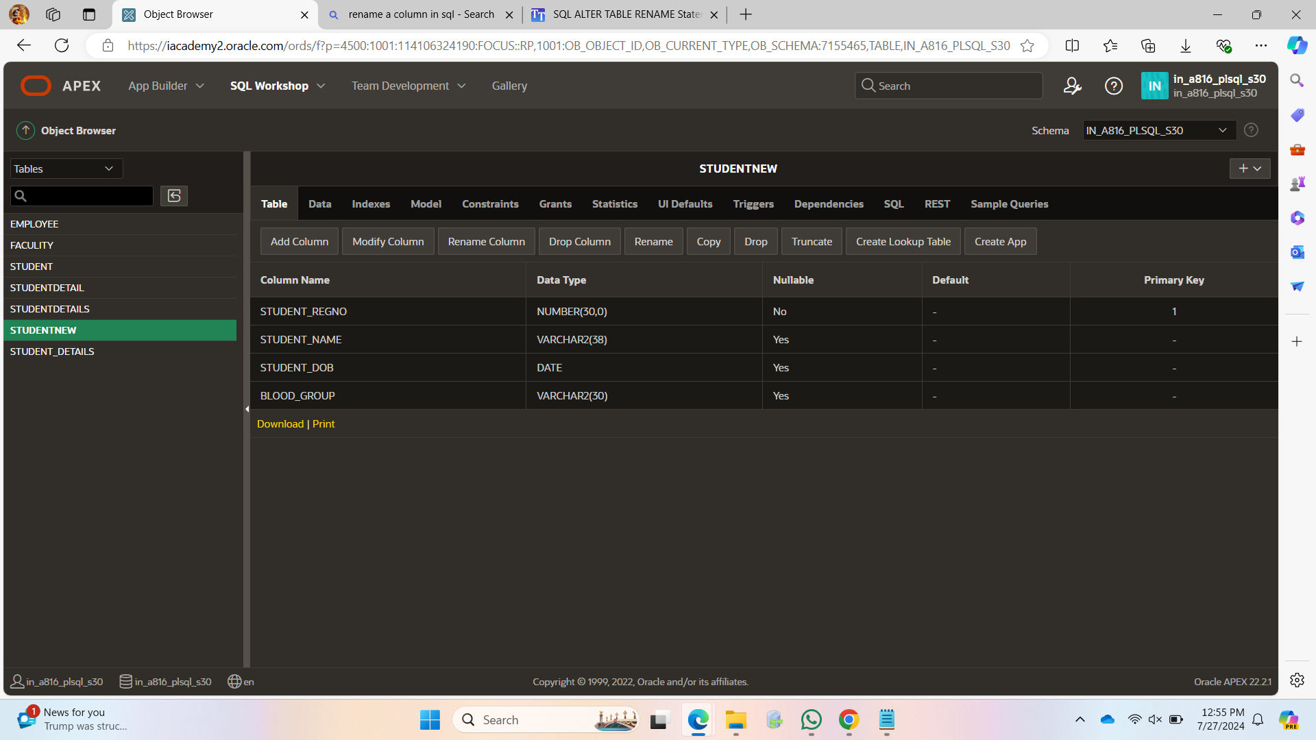

ALTER TABLE STUDENTNEW

MODIFY STUDENT_NAME VARCHAR2(38) NOT NULL;

ALTER TABLE STUDENTNEW

MODIFY STUDENT_DOB NUMERIC NOT NULL;

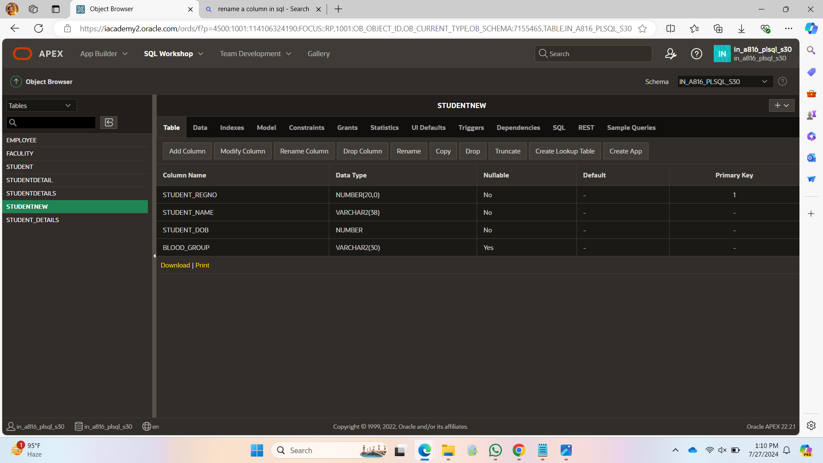

INSERT INTO STUDENTNEW VALUES(192371040,' ',2006,'Apositive');

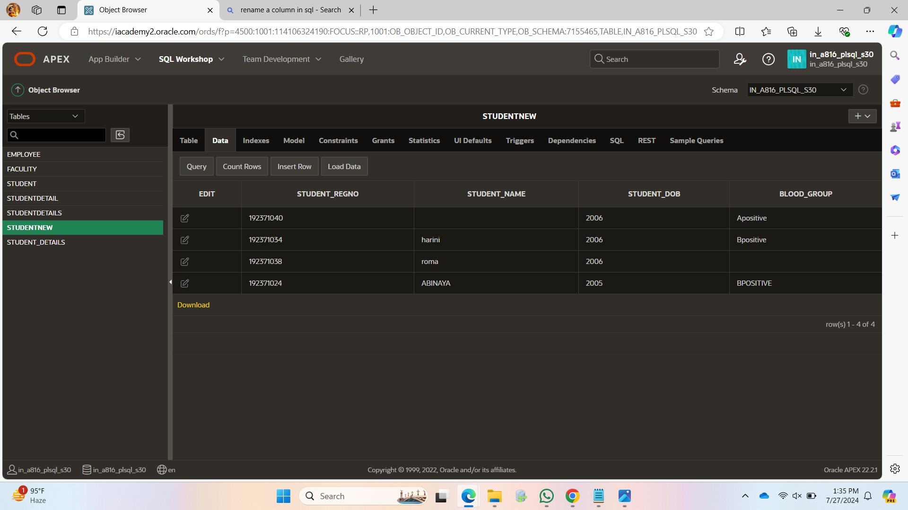

SELECT * FROM STUDENTNEW

ORDER BY STUDENT_REGNO DESC;

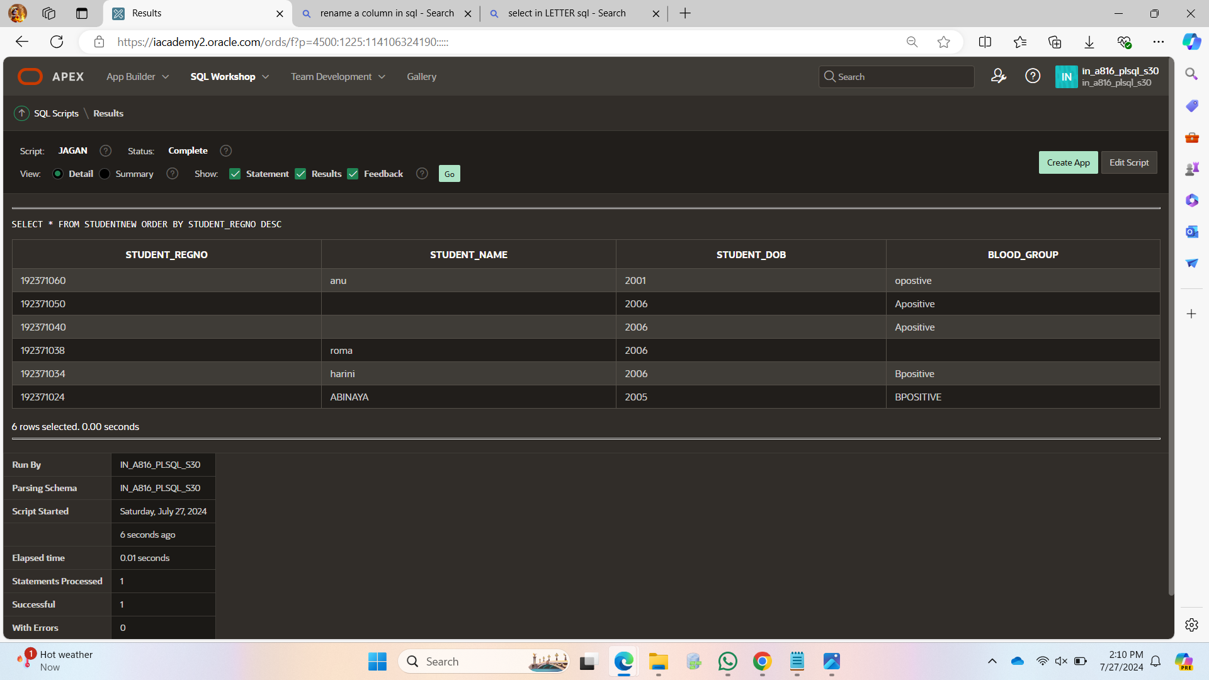

SELECT STUDENT_NAME FROM STUDENTNEW WHERE STUDENT_NAME LIKE 'A%';

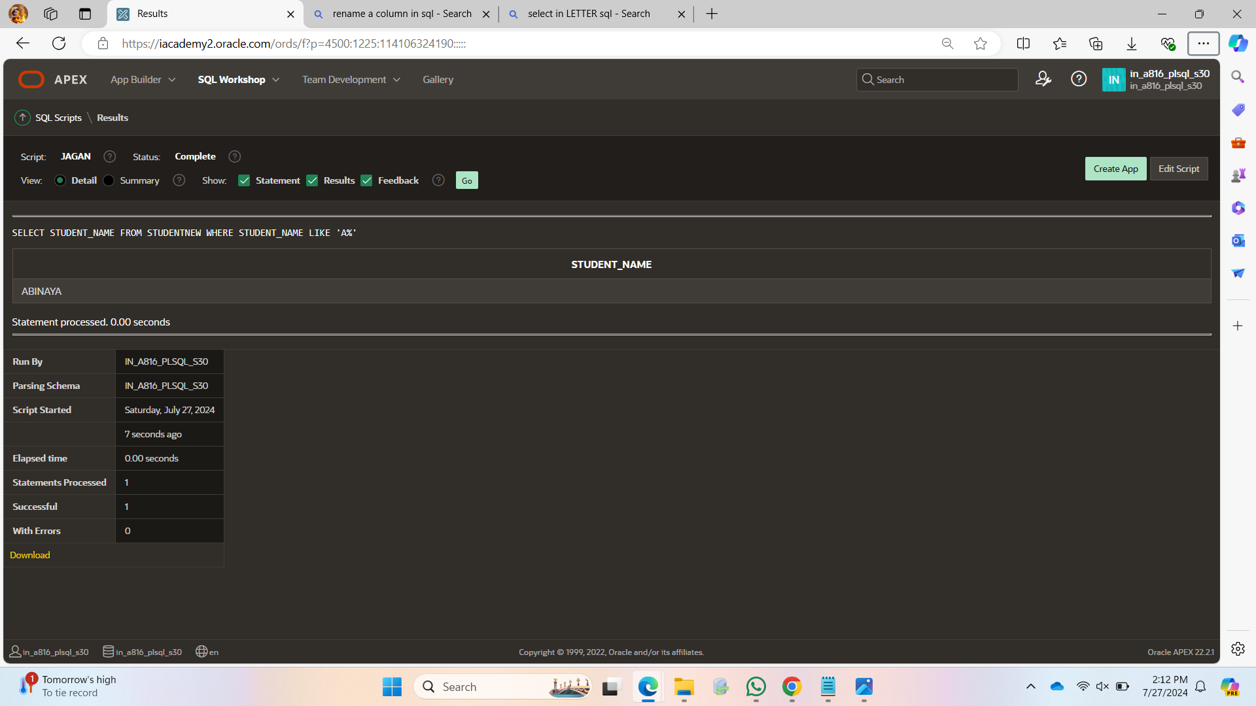

SELECT * FROM STUENTNEW WHERE STUDENT_DOB BETWEEN 2005 AND 2006;

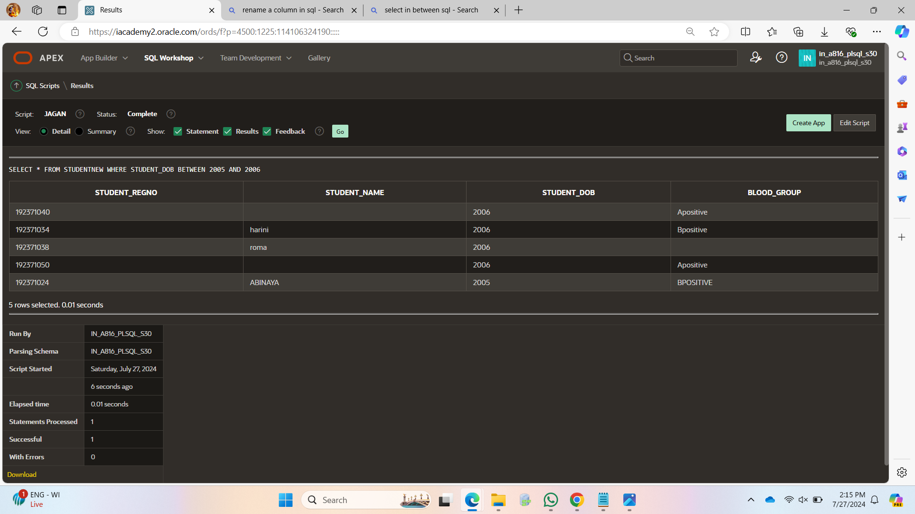

SELECT STUDENT_DOB, STUDENT_DOB+1 AS "STUDENT_DOB+1"

FROM STUDENTNEW;

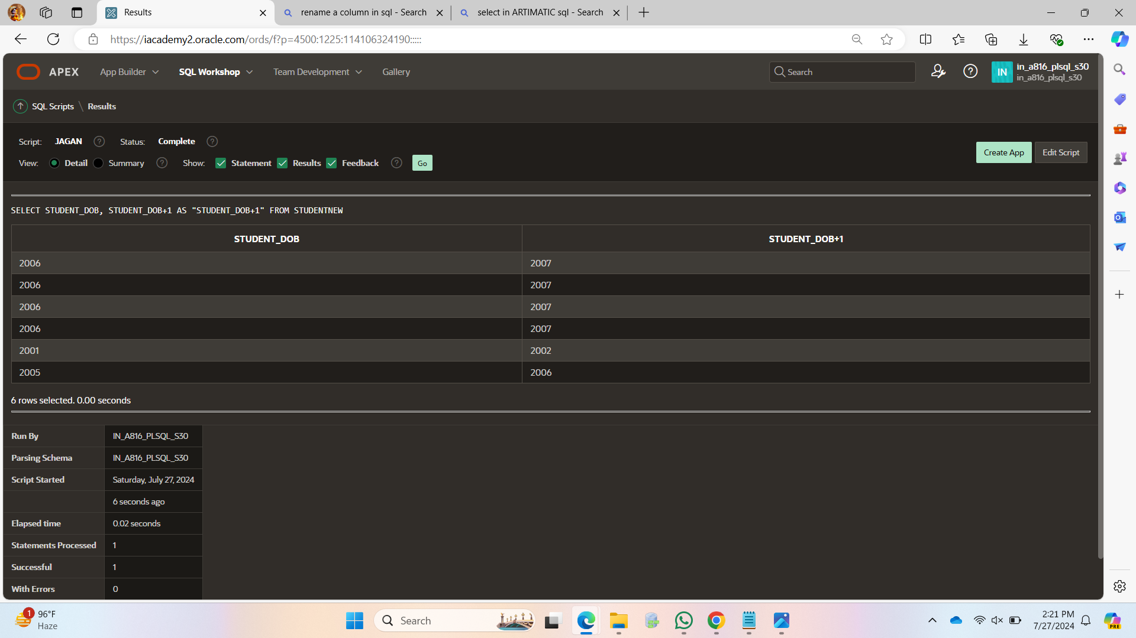

SELECT * FROM STUDENTNEW WHERE STUDENT_DOB>2006

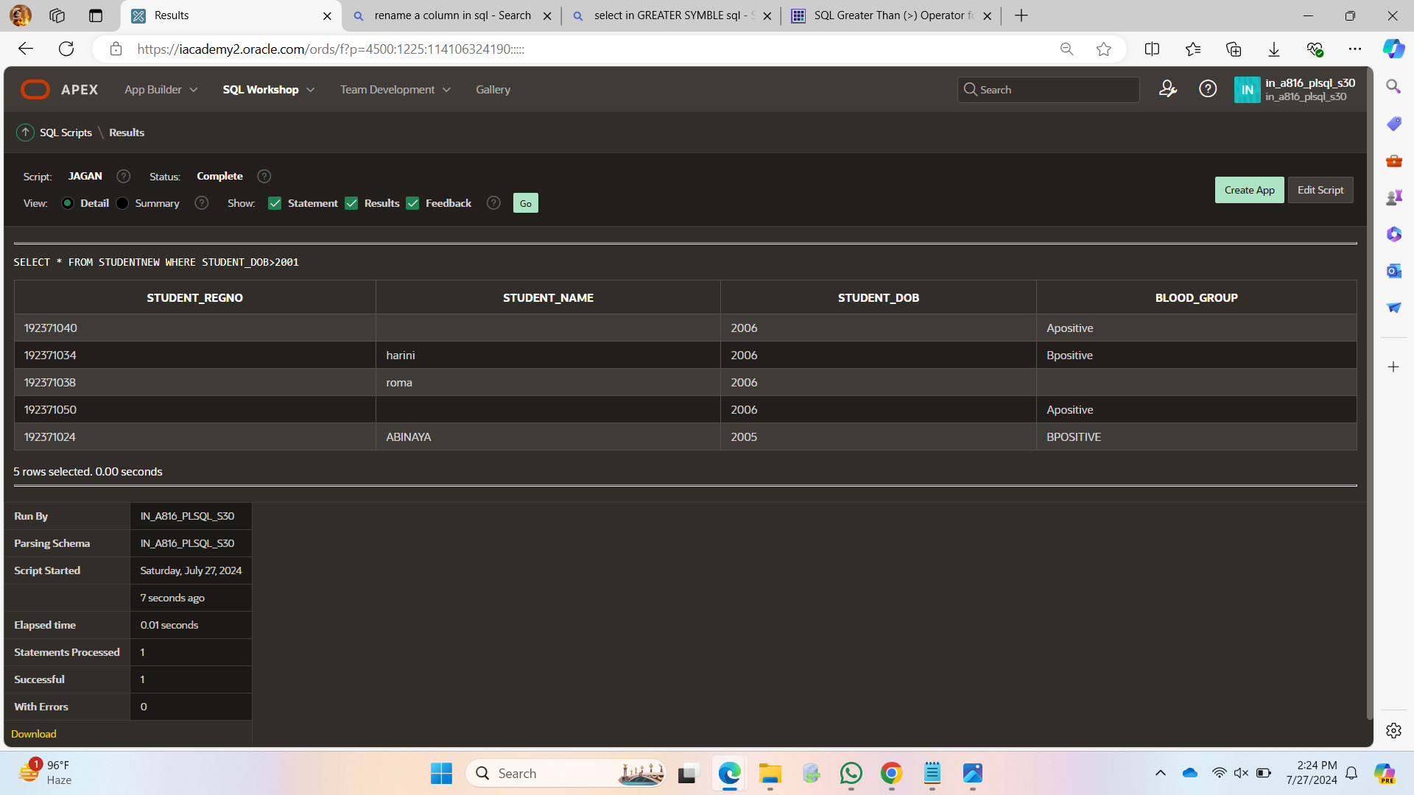SELECT * FROM STUDENTNEW WHERE STUDENT_REGNO = 192371024 OR STUDENT_REGNO = 192371034 _REGNO = 192371034;

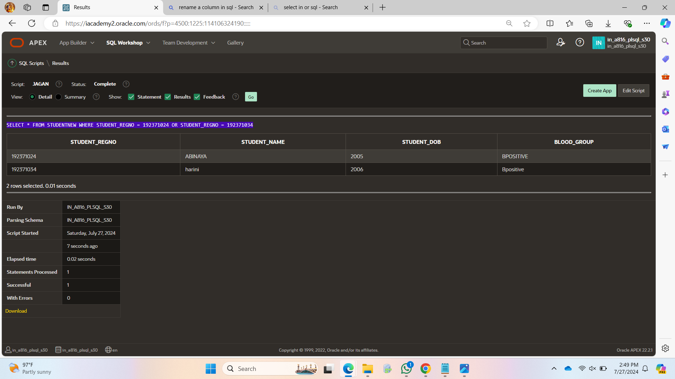

DELETE FROM STUDENTNEW ;

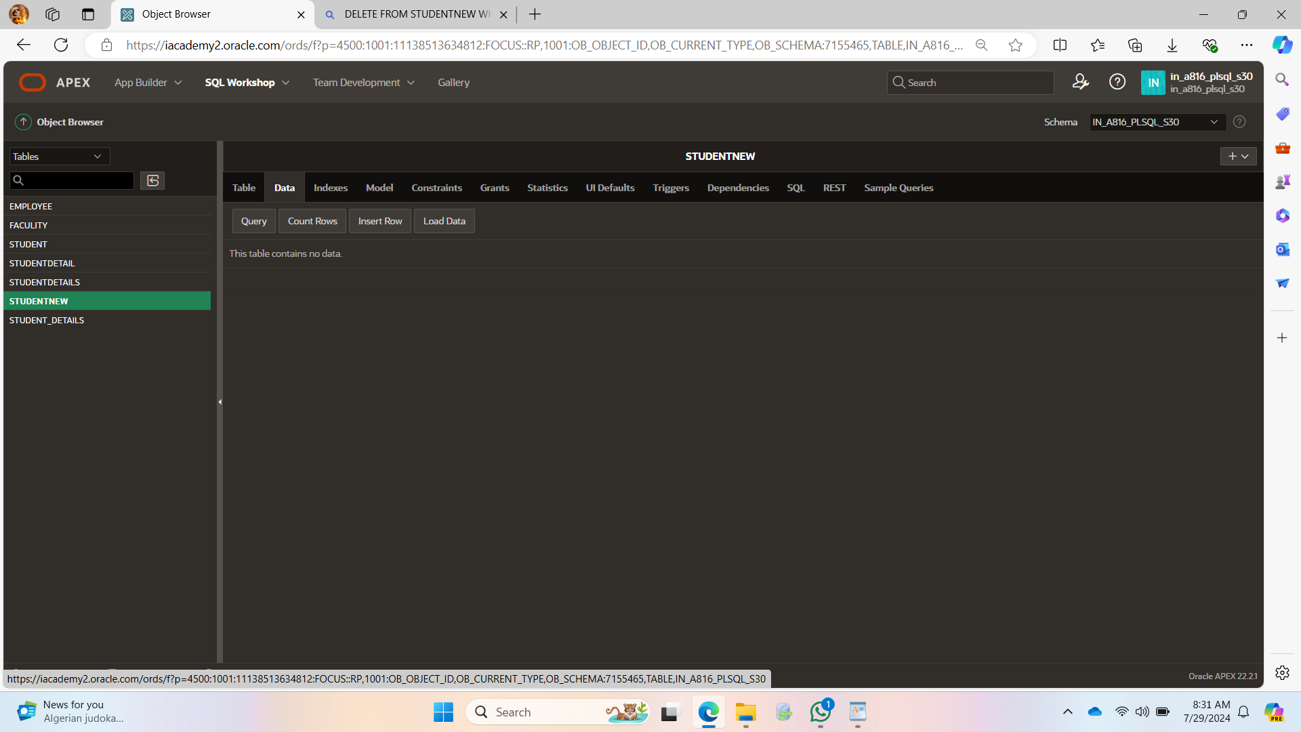

DROP TABLE STUDENTNEW;

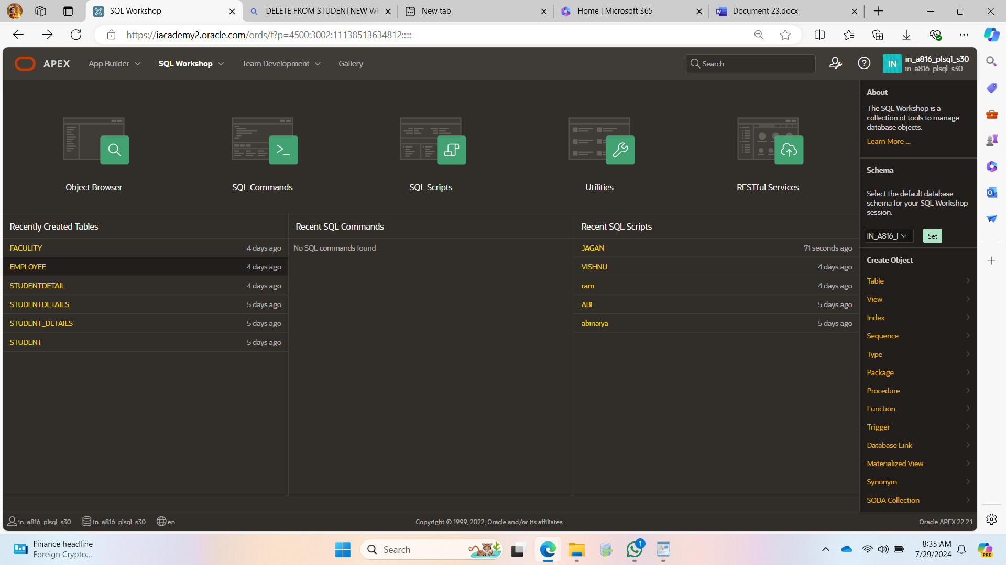

SELECT Marks AS Student_marks FROM Student3;

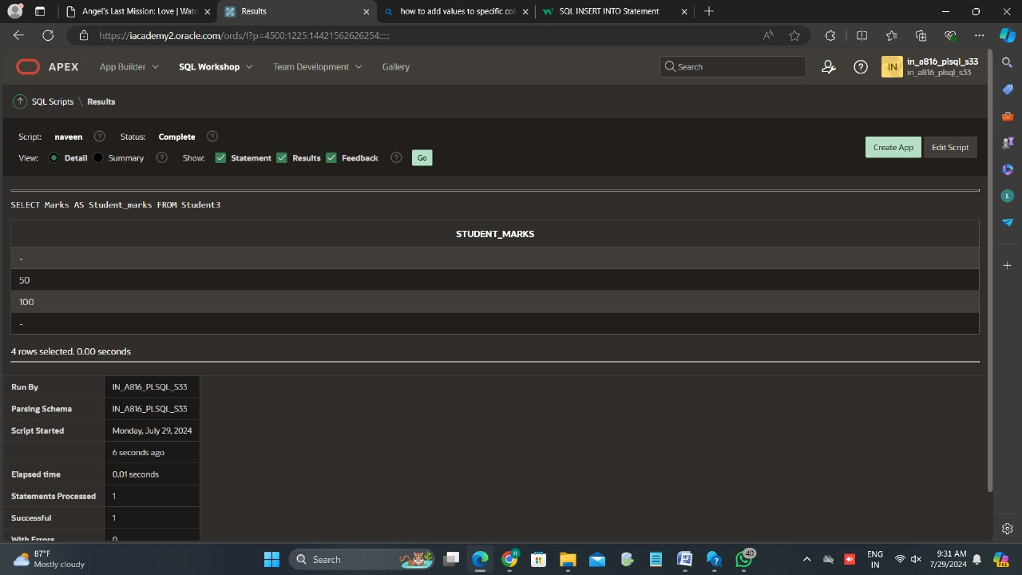

Alter table Orders add foreign key (Person_id) references Person(Person_id);

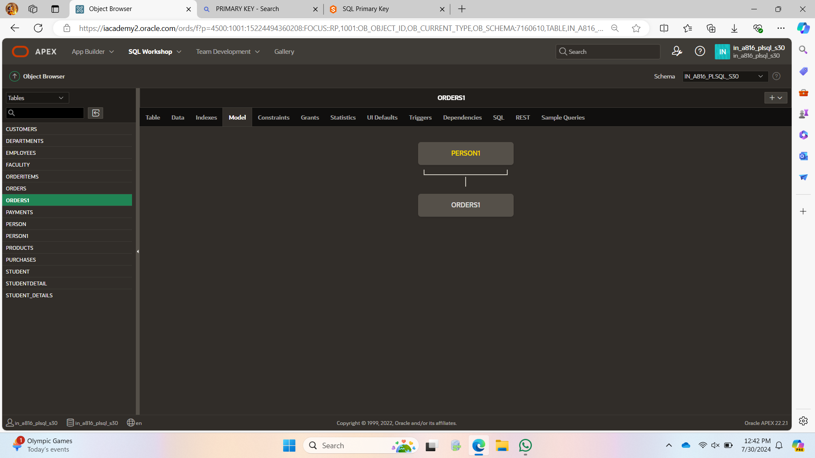

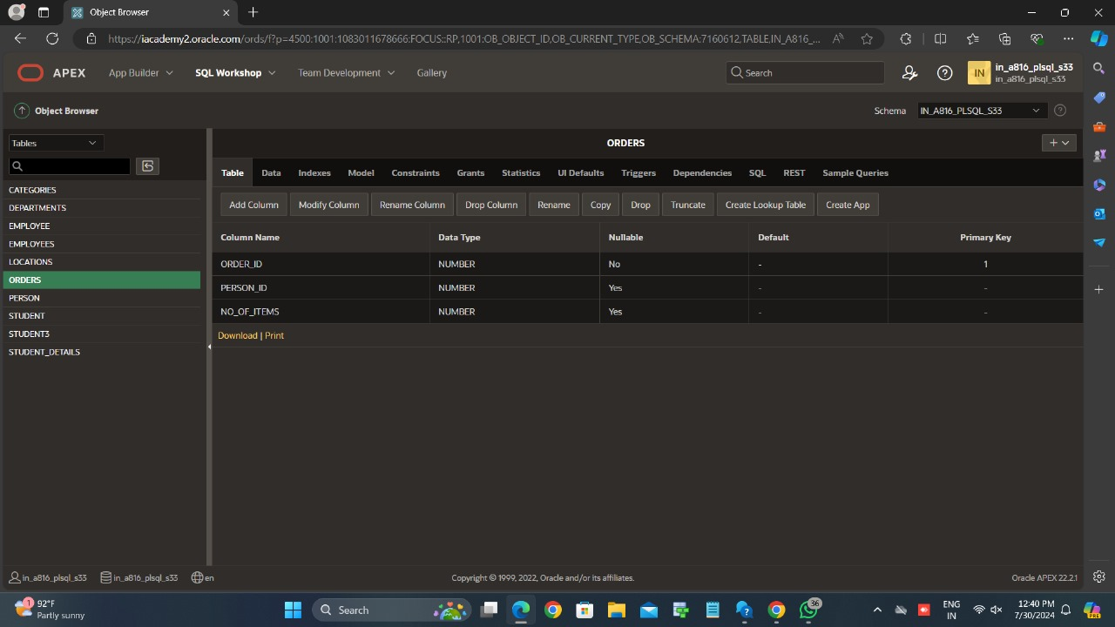

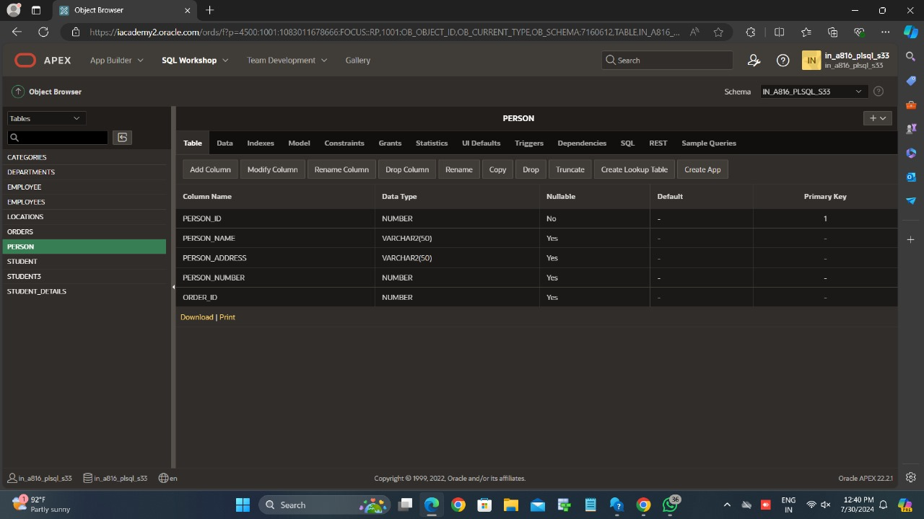

SELECT * FROM ORDERS1 JOIN PERSON1 ON ORDERS1.PERSON_ID = PERSON1.PERSON_ID;

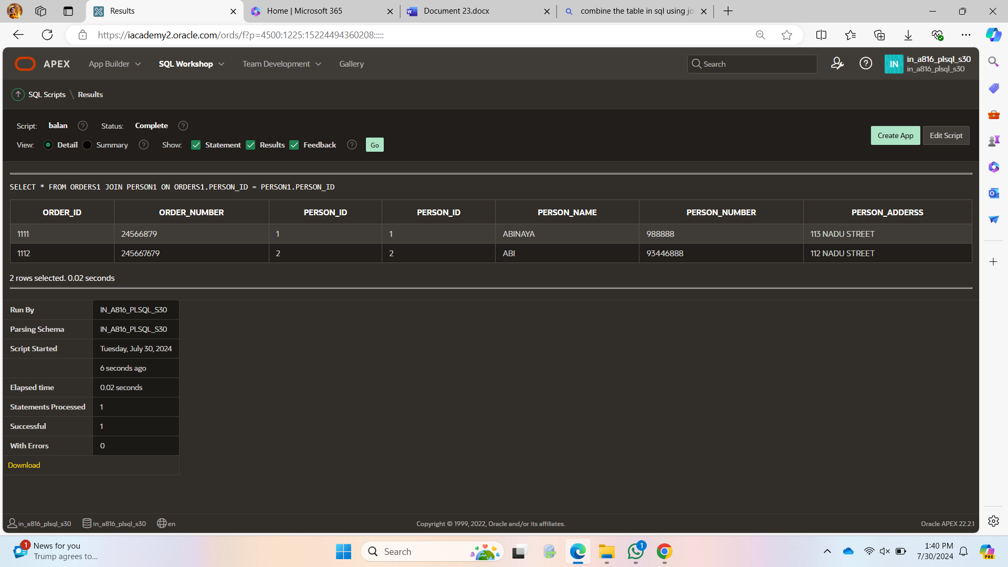

SELECT LAST_NAME,CASE DEPARTMENT_ID

WHEN 100 THEN 'MANAGEMENT'

WHEN 101 THEN 'SALES'

WHEN 102 THEN 'IT'

ELSE 'OTHER DEPT.'

END AS "DEPARTMENT"

FROM EMPLOYEENEW;

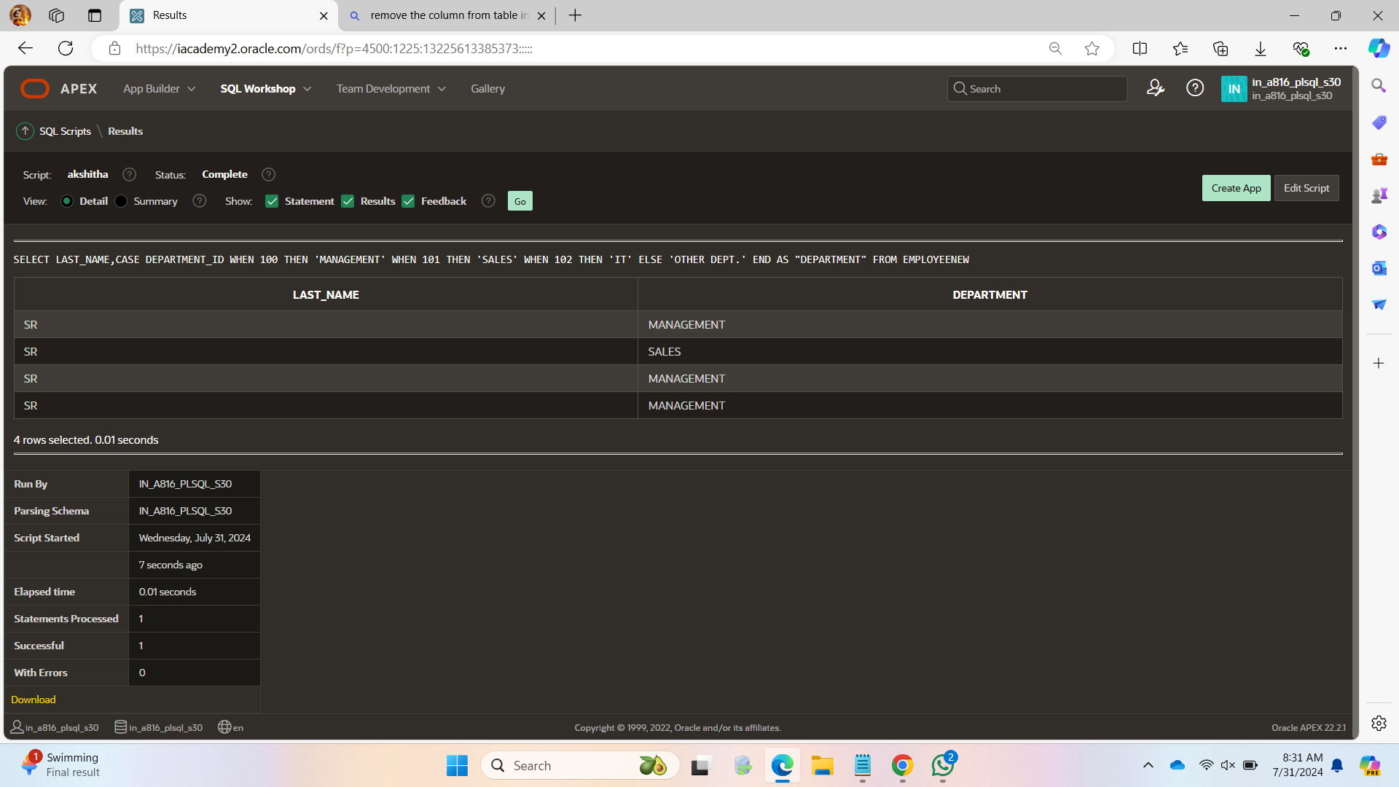

SELECT employee_id, last_name, job_id, job_title

FROM emp NATURAL JOIN jobs

WHERE employee_id > 80;

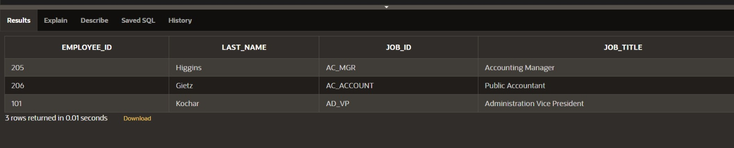B

SELECT FIRST_NAME ,LAST_NAME,DEPARTMENT_ID,DEPARTMENT_NAME FROM EMPLOYEE3 JOIN DEPARTMENT3 USING (DEPARTMENT_ID)

WHERE LAST_NAME ='SR';

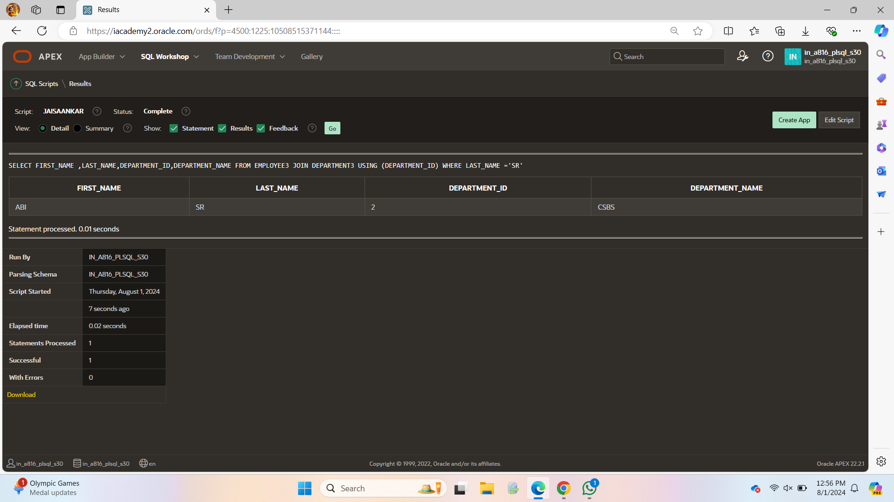

SELECT FIRST_NAME ,LAST_NAME,DEPARTMENT_ID,DEPARTMENT_NAME FROM EMPLOYEE3 JOIN DEPARTMENT3 USING (DEPARTMENT_ID);

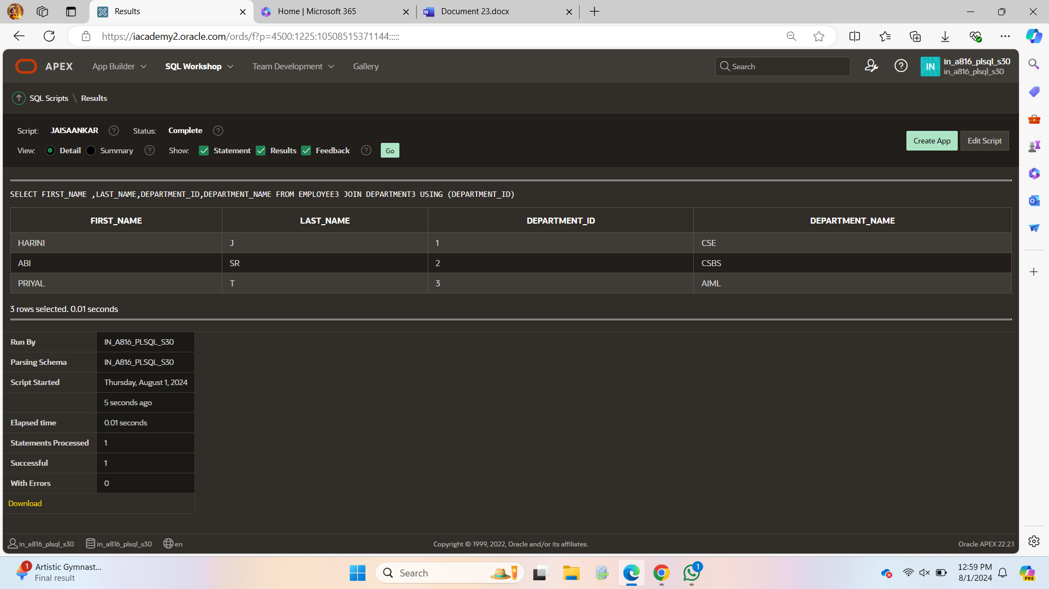

SELECT EMPLOYEE3.FIRST_NAME ,EMPLOYEE3.LAST_NAME,EMPLOYEE3.DEPARTMENT_ID,EMPLOYEE3.DEPARTMENT_NAME FROM EMPLOYEE3 JOIN DEPARTMENT3 ON (EMPLOYEE3.DEPARTMENT_ID=DEPARTMENT3.DEPARTMENT_ID);

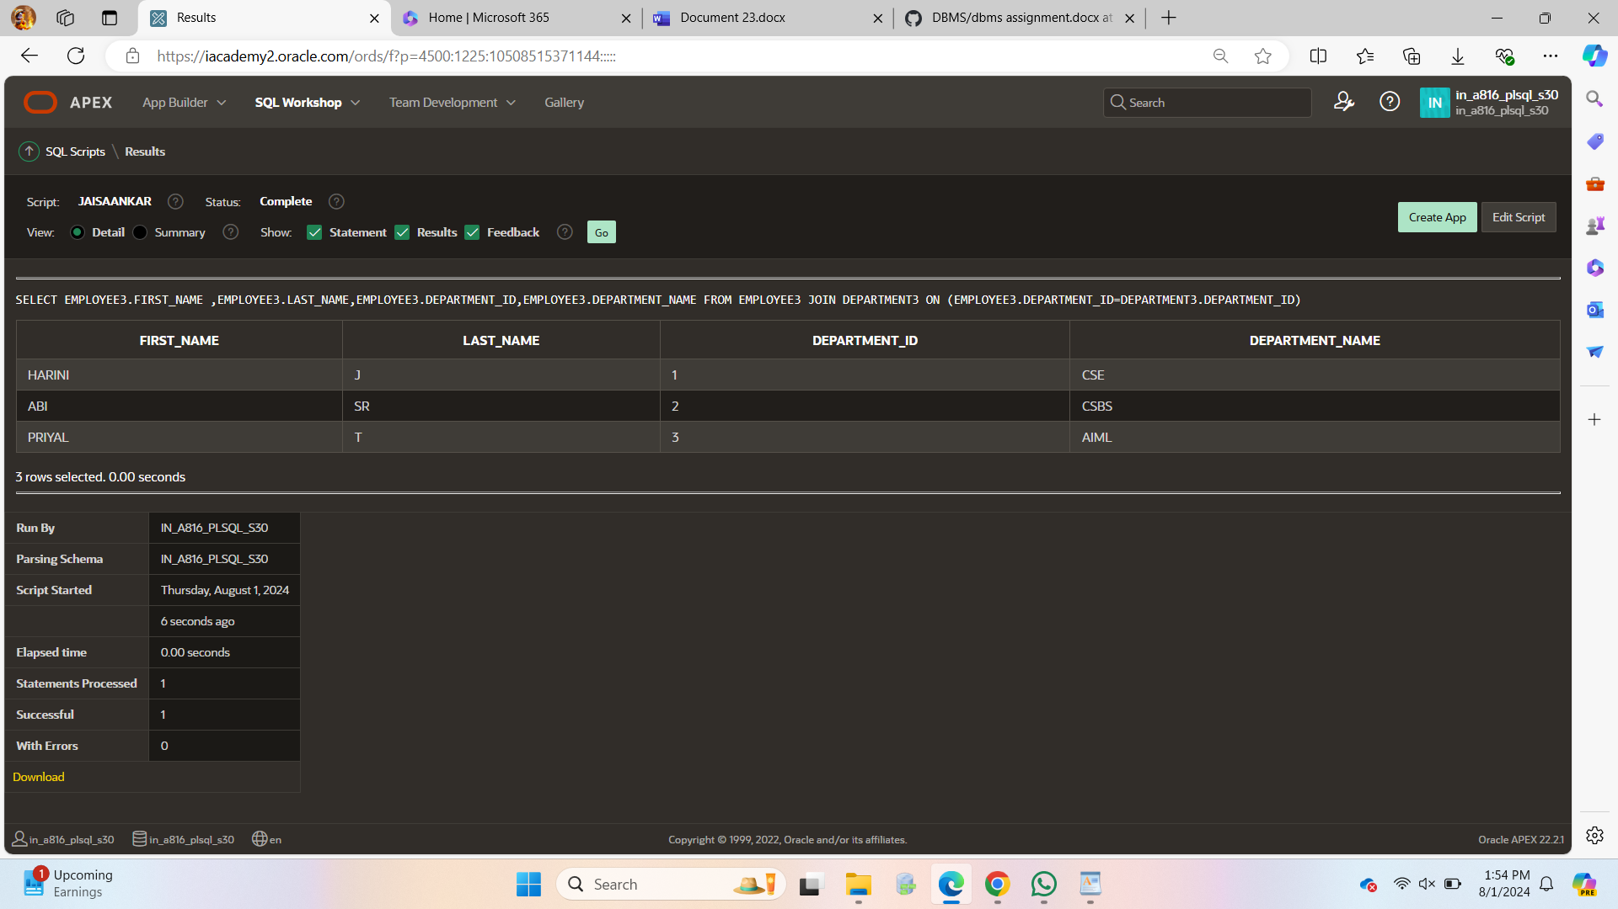

SELECT EMPLOYEE3.FIRST_NAME ,EMPLOYEE3.LAST_NAME,EMPLOYEE3.DEPARTMENT_ID,EMPLOYEE3.DEPARTMENT_NAME FROM EMPLOYEE3 JOIN DEPARTMENT3 ON (EMPLOYEE3.DEPARTMENT_ID=DEPARTMENT3.DEPARTMENT_ID)

WHERE FIRST_NAME LIKE 'A%';

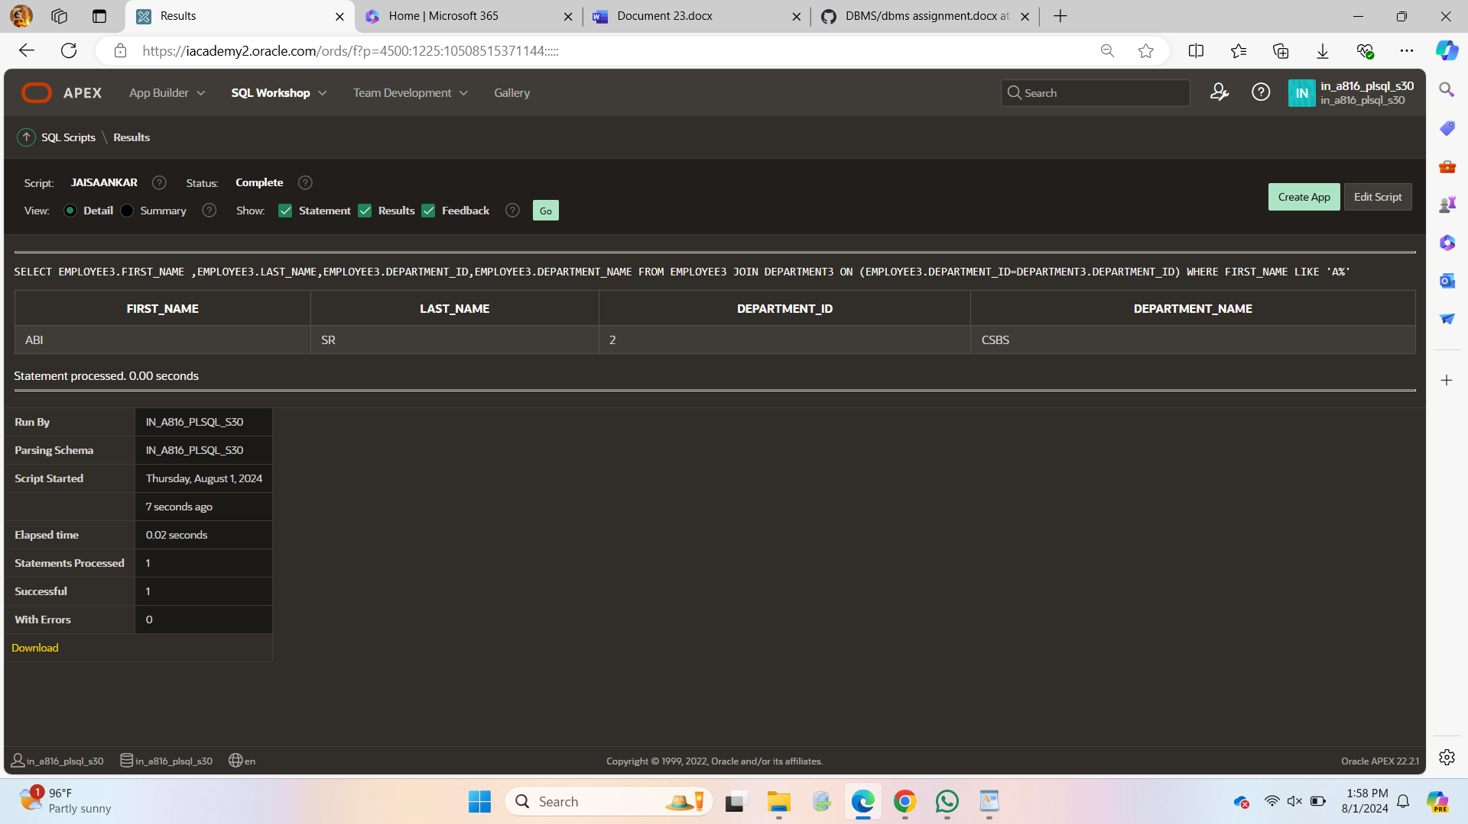

SELECT FIRST_NAME,DEPARTMENT_NAME AS "DEPARTMENT",LAST_NAME FROM EMPLOYEE3 JOIN DEPARTMENT3 USING (DEPARTMENT_ID)

JOIN FACULTY3 USING (FACULTY_NAME);

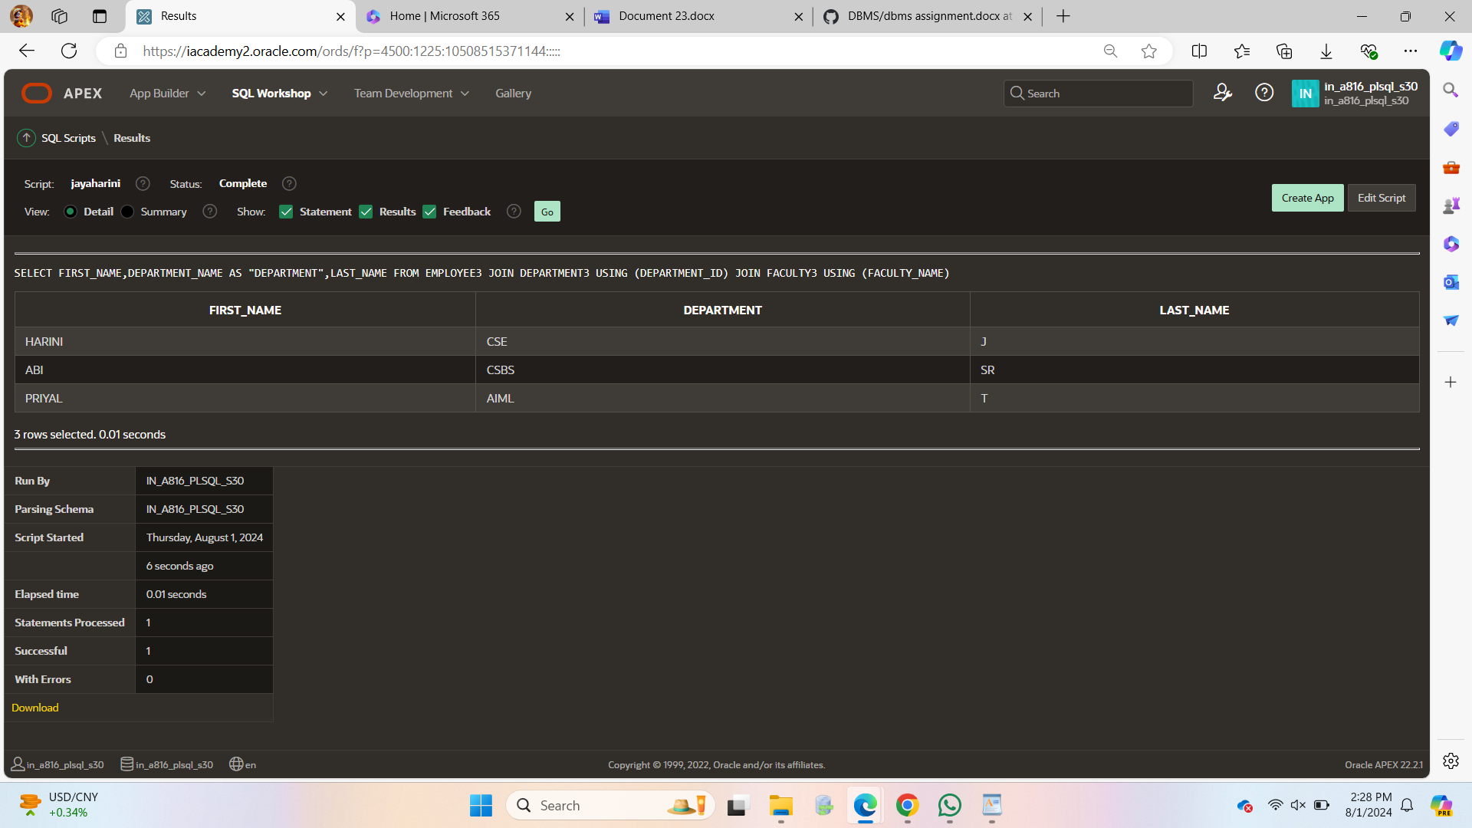

SELECT e.LAST_NAME,e.DEPARTMENT_ID FROM EMPLOYEE3 e LEFT OUTER JOIN

DEPARTMENT3 d ON (e.DEPARTMENT_ID = d.DEPARTMENT_ID);

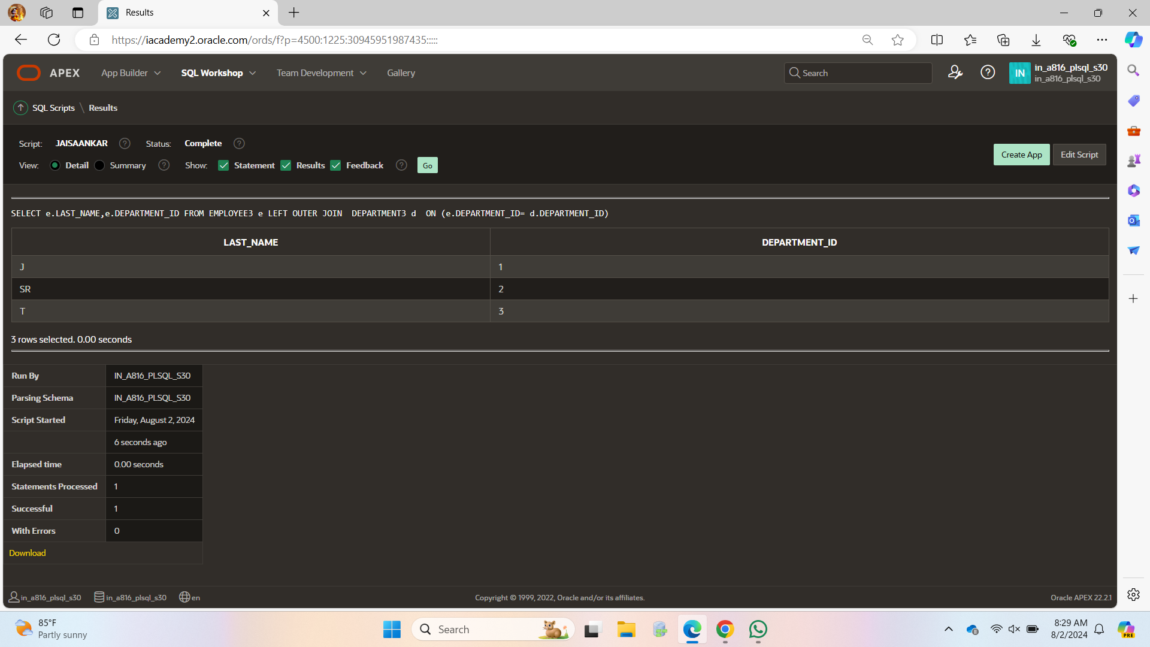

FULL

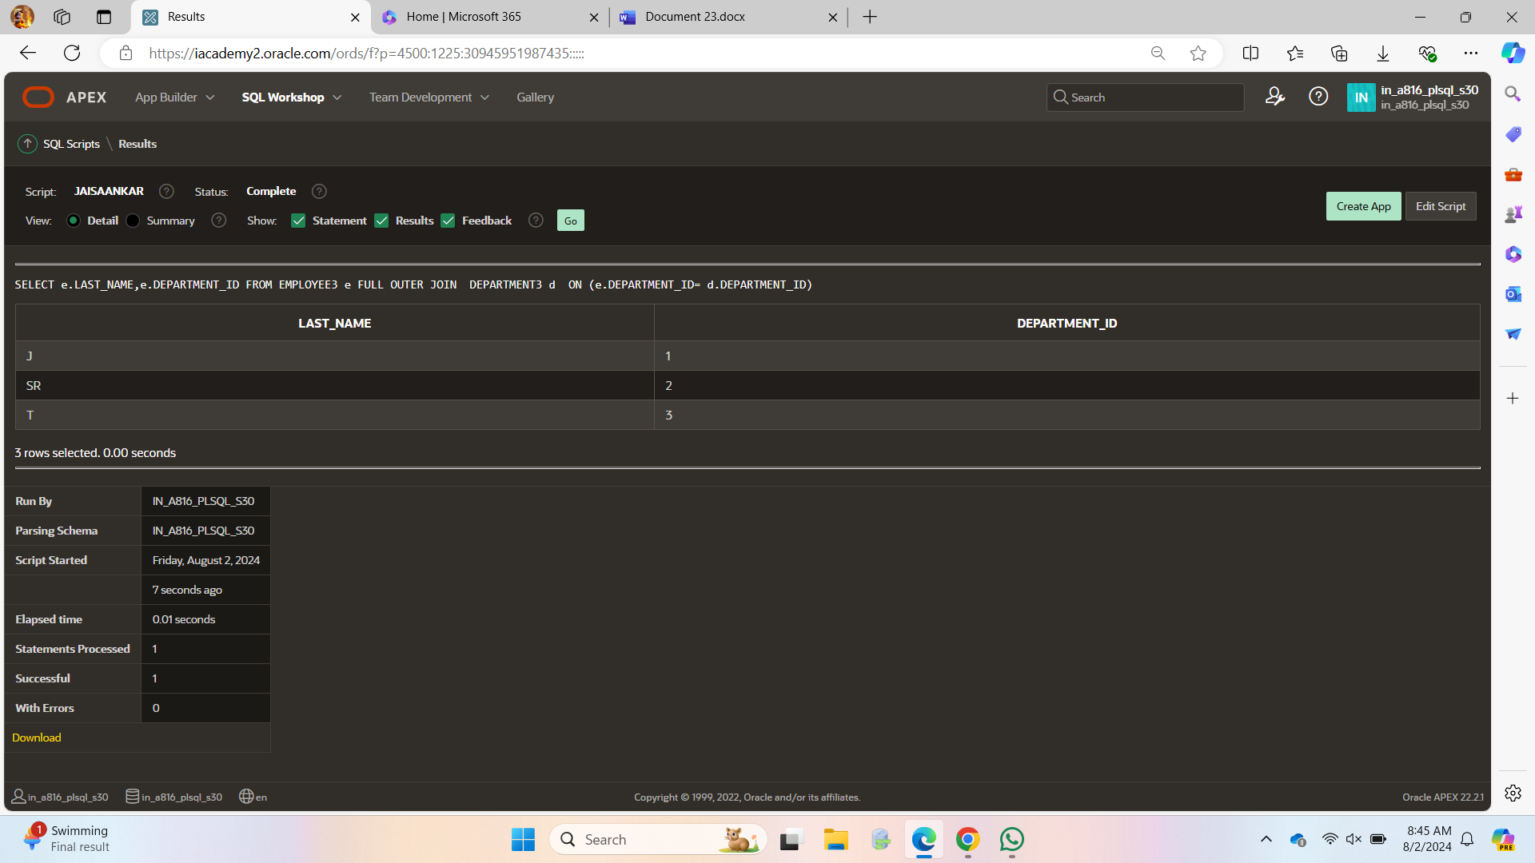

RIGHT

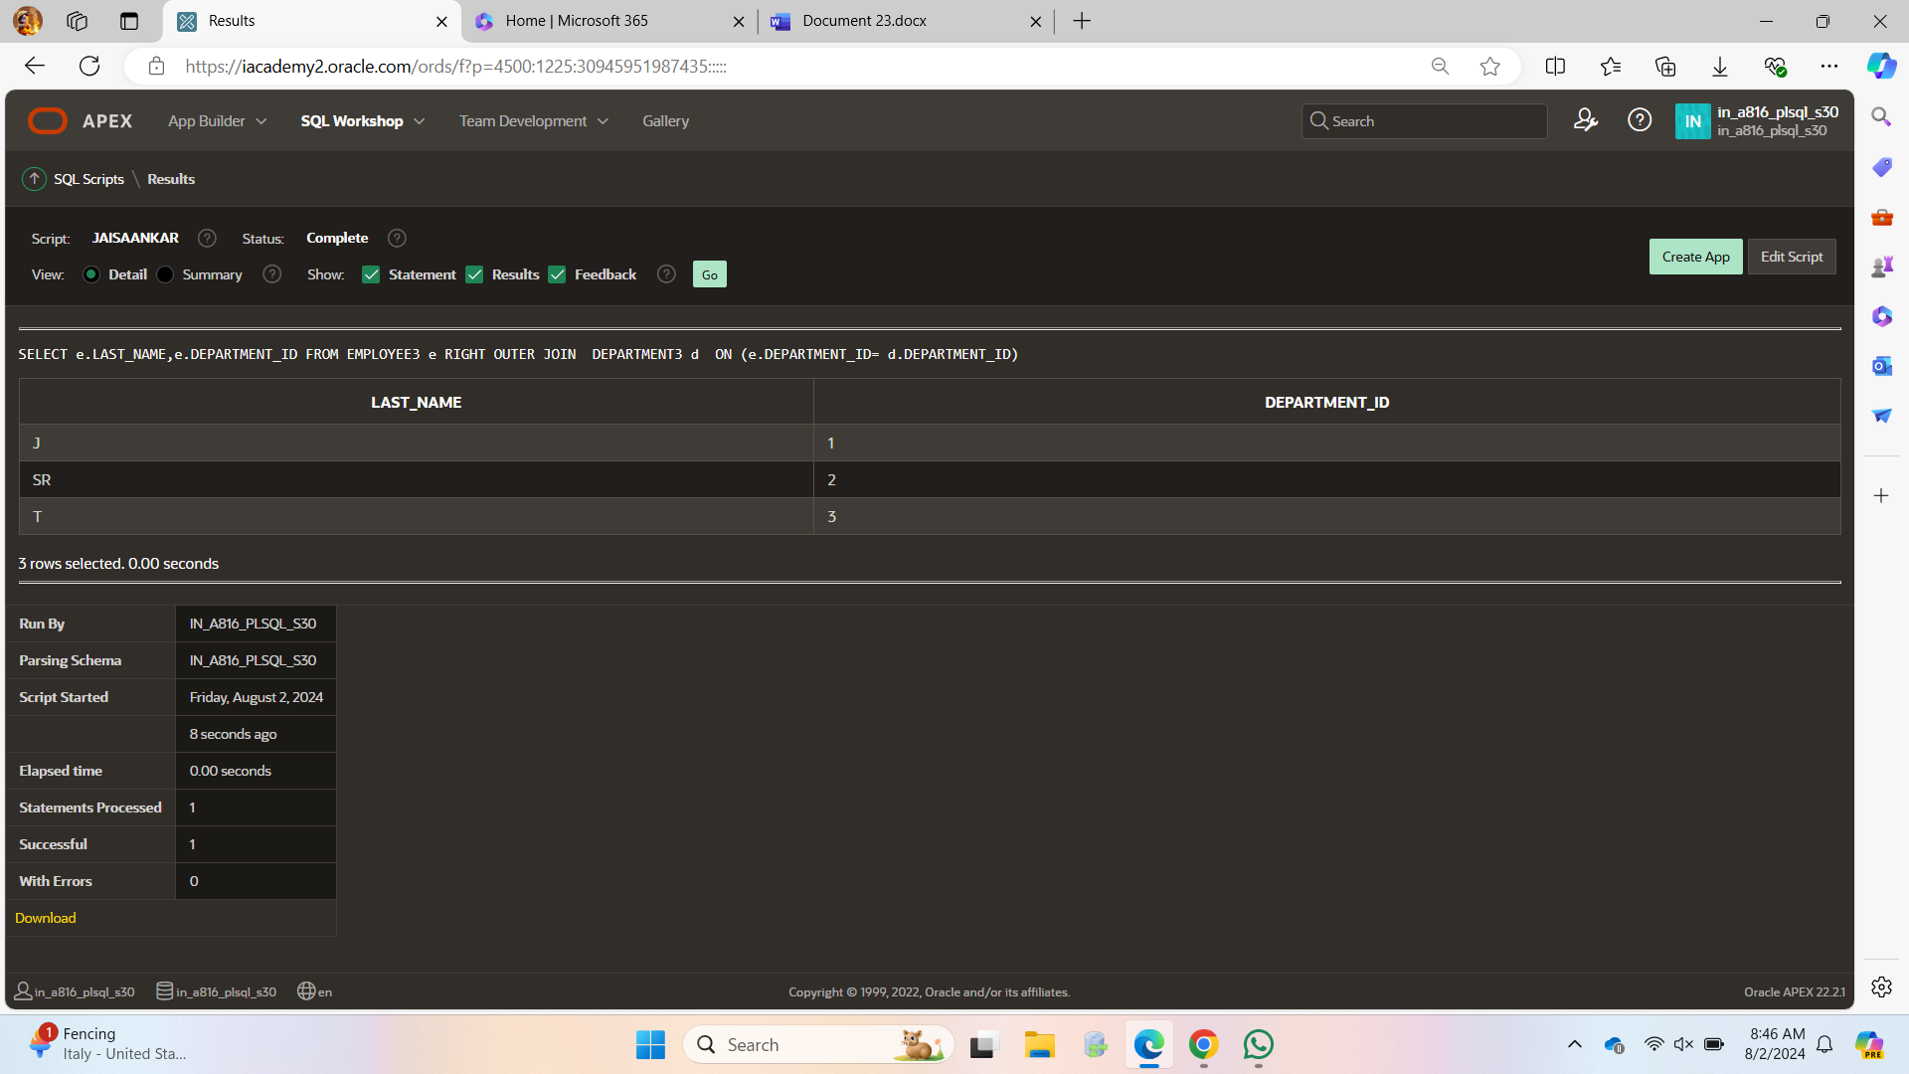

SELECT FIRST_NAME,LAST_NAME,DEPARTMENT_NAME

FROM EMPLOYEE3 CROSS JOIN

DEPARTMENT3;

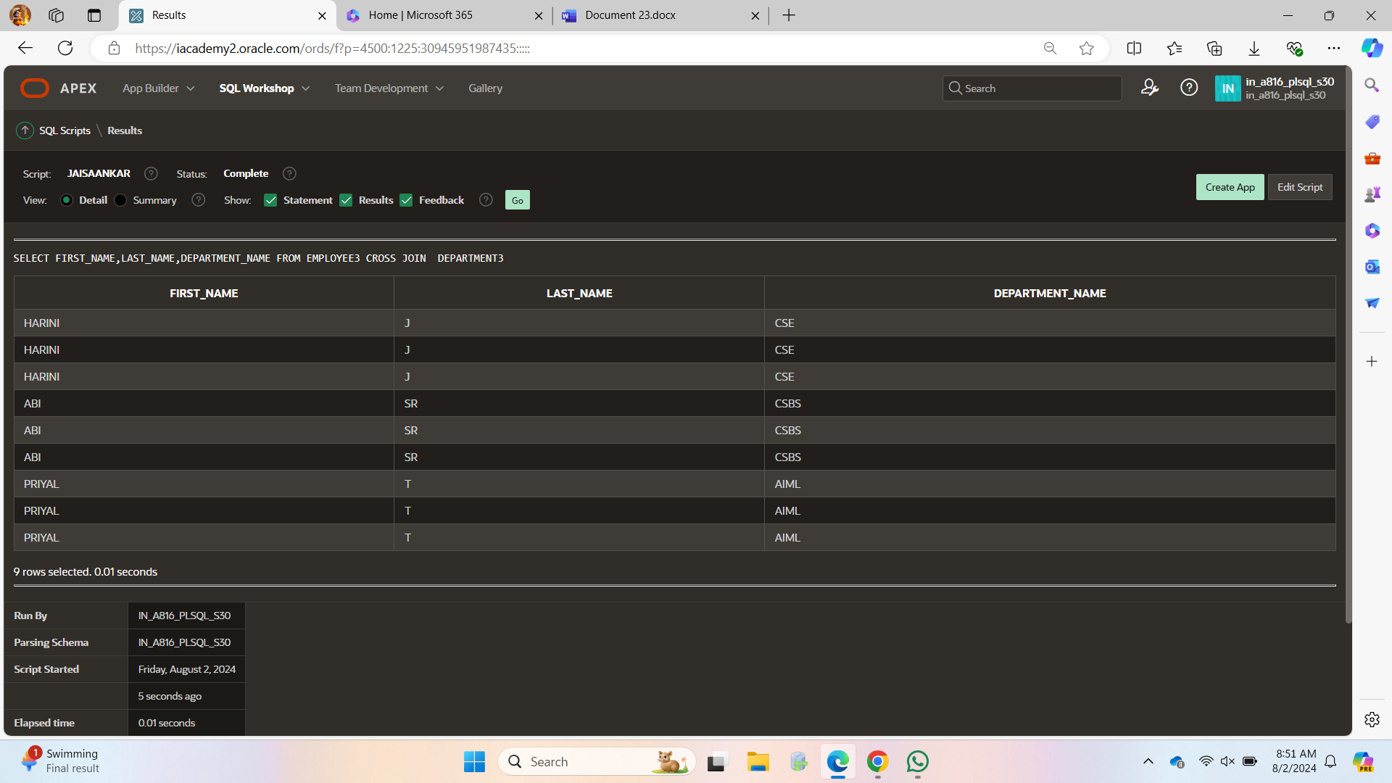SELECT e.FIRST_NAME||'workfor'||d.FACULTY_NAME

AS " Worksfor "

FROM EMPLOYEE3 e JOIN

DEPARTMENT3 d ON (e.DEPARTMENT_ID=d.DEPARTMENT_ID);

